

**Lab Manual- Generate YAML from Helm Chart**

**Prepared for**:

**Date:** 18th Dec 2023

**Prepared by:**

Document Name: Lab Manual **Document Number** AZLabn916

**Contributor:**

Contents

1. Objective 3

2. Generate Deployment YAML from Helm 3

3. Deploy the YAML 4

4. Delete the deployment 5

# Objective

Helm charts are structured like this:

mychart/

Chart.yaml

values.yaml

charts/

templates/

...

The **templates/** directory is for template files. When Tiller evaluates a chart, it will send all of the files in the **templates/** directory through the template rendering engine. Tiller then collects the results of those templates and sends them on to Kubernetes.

The **values.yaml** file is also important to templates. This file contains the *default values* for a chart. These values may be overridden by users during helm install or helm upgrade.

The **Chart.yaml** file contains a description of the chart. You can access it from within a template. The charts/ directory *may* contain other charts (which we call *subcharts*). Later in this guide we will see how those work when it comes to template rendering.

**But another step you can take as you can convert that chart into standard Kubernetes YAML. Therefore, you can apply that to any cluster without having Helm present. It's a kind of optional**

# Generate Deployment YAML from Helm

1. Type below command to add bitnami repo

helm template webapp ./nginx > niinx-demo.yaml



1. List content of the yaml

cat niinx-demo.yaml

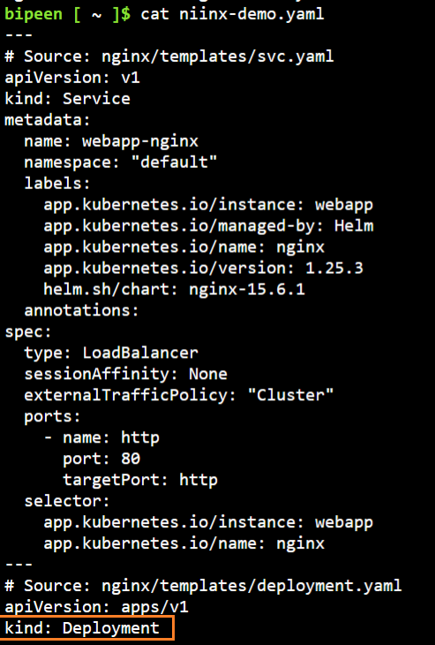

# Deploy the YAML

kubectl apply -f niinx-demo.yaml

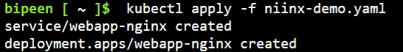

kubectl get po

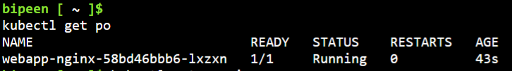

kubectl get service

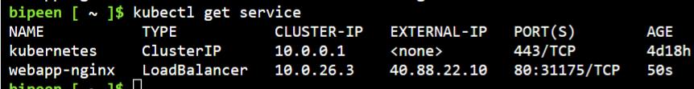

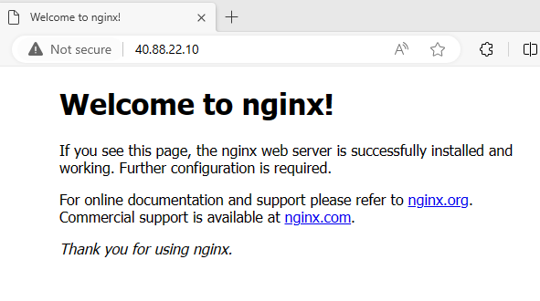

# Delete the deployment

kubectl delete deployment webapp-nginx

kubectl delete service webapp-nginx

